*Create table and do the following questions*

1. Create table name as workers
2. Insert values into the table in given question
3. To add the column of the salary
4. *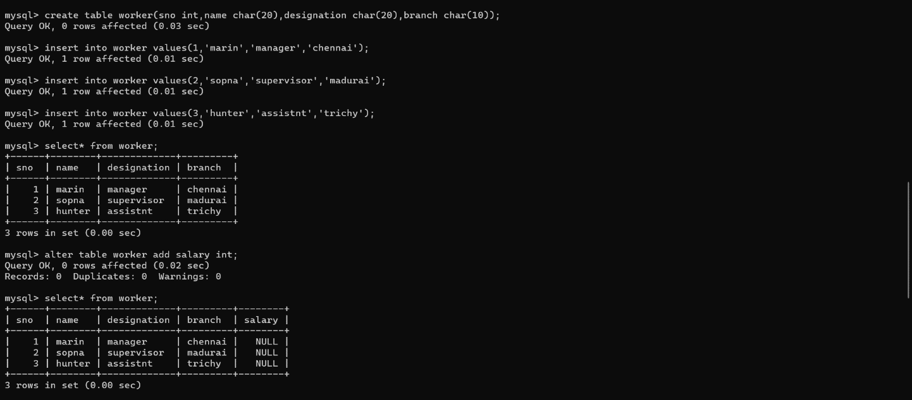*Alter modify the table name
5. Then describe the table workers
6. Copy same as trainee
7. Then delete the second row in the table
8. *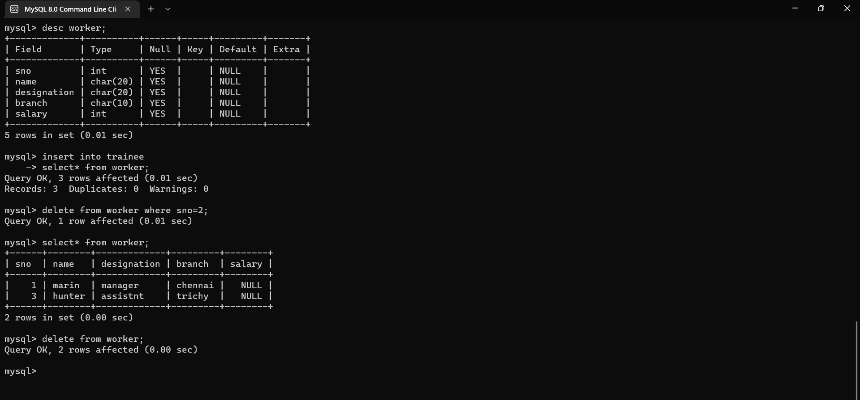*Then drop the table